Student guide: Names:
Guiding Question:
How do the properties of amplitude and frequency affect wavelength?
Start: Begin the simulation on the moodle
- For this activity you will be collecting data to explore three properties of a wave.
-  Explore the simulation with your partner. Be sure to click on all the buttons.
- For the first set of investigations, we will look at amplitude.
  - you need to be on
  - The rest of your screen should be set up like this:(Note how the rulers are positioned)
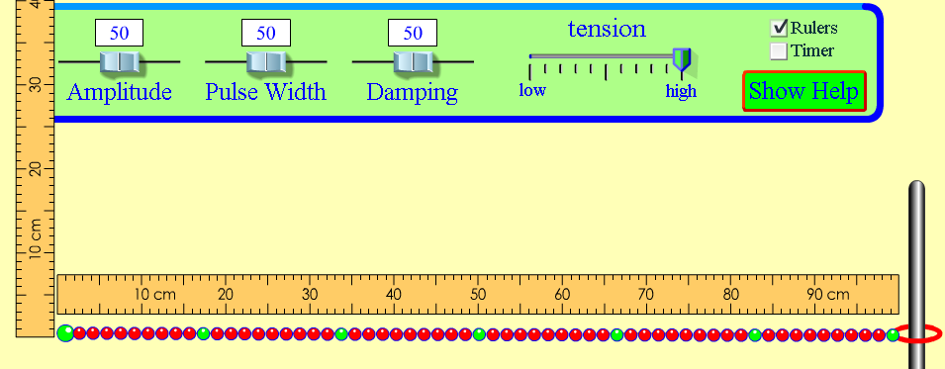
Look over the data table, on the back, and discuss how to get the data you need.
 moves the wave.

Amplitude setting | Height of wave at the start  (be sure your ruler is lined up correctly) | Distance ring moves on pole (end)
100
50
5
Discuss what happened to the energy at the end of the wave when we changed the amplitude. Be prepared to share your thoughts on this with the class
- Repeat number 4 – using and then (Use the same amplitudes from the chart)
What did you notice in general happened to the wave with the fixed end?

What did you notice in general happened to the wave with the no end?

- For this next part we will investigate wavelength.
  - You need to be on
  - The rest of your screen should be set up like we did for number 4.
  - Try out the  button after you hit pause. This may be useful for collecting data.
Data:
wavelength = _______ cm

Wavelength = _____ cm
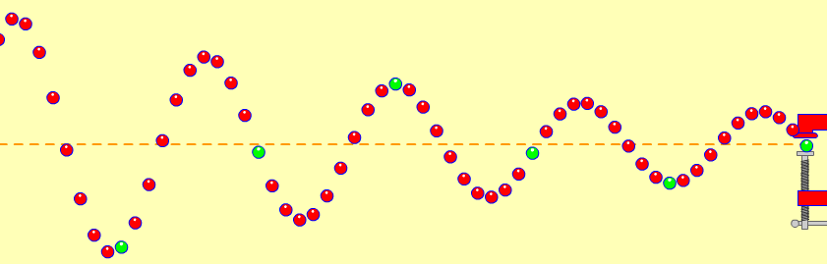
7. Talk about the wavelength of the two waves you measured.
- Discuss how they were similar and how they were different.

- Do the same thing for fixed end and note your observations

- Now, do the same thing for no end and record your observations.

For the third set of investigations, we will look at frequency.
  - you need to be on
  - open both the ruler and timer
  - controlled variables: Amplitude and damping should be left on 50 and tension stays on “high”
  - Remember, to stop or slow the wave use pause/play and .
- Look over the data table and discuss how you will collect the data you need.
- Before you begin… try a little practice using the timer:
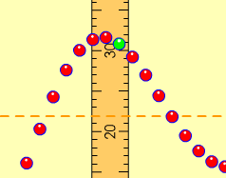
- Turn the timer on, off and reset the timer while waves are moving.
- Practice counting waves passing a given point:
- Move the vertical ruler so that it is along the wave’s path. This will be the point where you watch waves pass and count them. Count 5 waves passing the ruler. Change the frequency and count again.
- Fill in the table by working together counting the waves and using the timer.
Data:
frequency | Time interval | Number of waves: |  |  | Average number of waves counted in 10 second period | Number of waves in 1 second  _{frequency**}
frequency | Time interval | Trial #1 | Trial #2 | Trial #3 | Average number of waves counted in 10 second period | Number of waves in 1 second  _{frequency**}
50 | 10 seconds
10 | 10 seconds
100 | 10 seconds
*To find frequency, divide the average number of waves counted by the time interval.
5. Talk about the data.
- Decide on a way your group can explain wave frequency to the class.
- Write your idea(s) on the below.

Frame: Our data show that the higher the number chosen for the frequency on the slider, the _________________ the number of waves passing ____________________ in a certain amount of ________________________.

6. Use arrows, or draw on the wave, to show what will happen when the amplitude is increased:(To get an arrow go to insert then shapes)
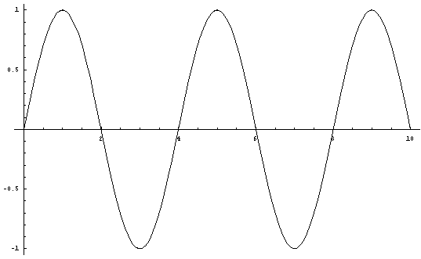
Line of --origin------
- Use arrows, or draw on the wave, to show what will happen when the frequency is increased:

Line of --origin------

